EXP-3
E- Commerce Mobile App Prototype (Figma)
Aim
To design a prototype for stakeholder feedback.
Requirements
Figma account and web browser.
Mobile frame for the e-commerce application.
Product, shopping cart, checkout, and confirmation UI screens.
Procedure
- Create mobile frame in Figma.
- Design Home, Product Page, Cart, Checkout.
- Create two UI variations (to resolve conflict).
- Present to stakeholders for feedback.
Observation
The e-commerce mobile app prototype was designed in Figma with screens for Home, Shop, Product, Shopping Cart, Checkout, and Order Confirmation. The prototype shows the user flow from browsing products to reviewing and placing an order.
Output
Output 1 – E-Commerce Mobile App Prototype in Figma
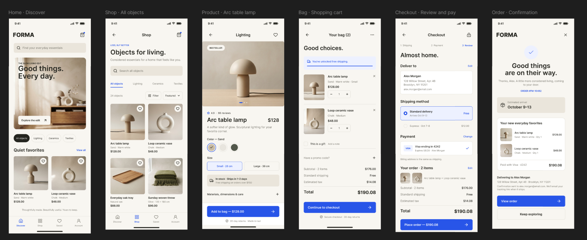
Result
Thus, an e-commerce mobile app prototype was successfully designed in Figma. The main screens and shopping flow were represented clearly for stakeholder feedback.

